**Concept Development**

**Problem Statement**

Harmonizing is difficult to learn and it can be hard to know whether your harmony is in tune with the melody.

**Proposed Idea**

The Harmonizer is a handheld device that allows amateur singers to practice harmonizing with a given note or melody line. It will play a note for the user, display the note being played and the note that must be sung, and use a microphone to rate the attempted harmony as either sharp, flat, or in-key.

**Influences**

Chromatic tuner- Uses an internal microphone to hear notes, displays the name of the note being played, indicates how far from in-tune it is by the red lights at the top and the cursor

on the screen.

*Source: https://www.amazon.com/Korg-CA1-Chromatic-Tuner/dp/B002PMHAVS*

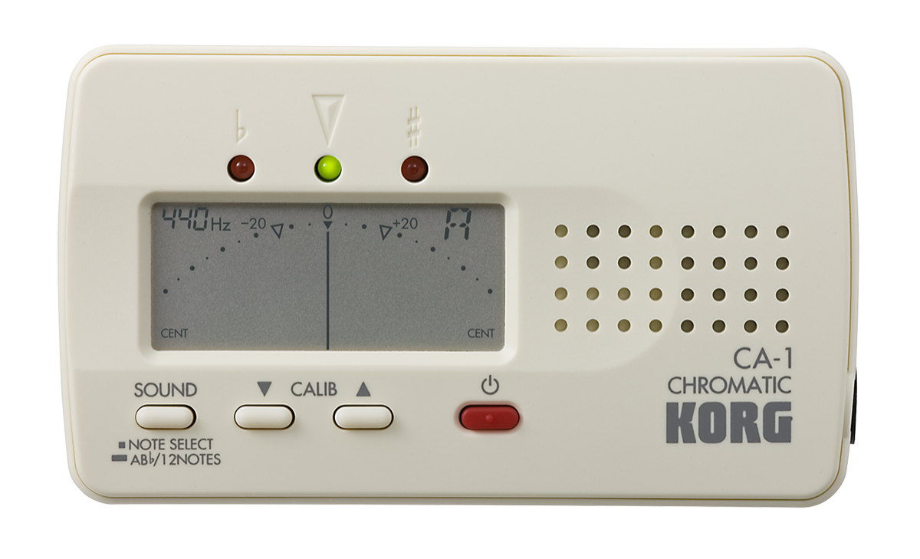

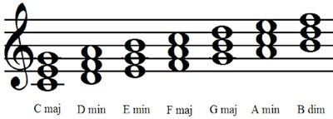

Chord chart- Displays the notes that make up a chord on a musical staff

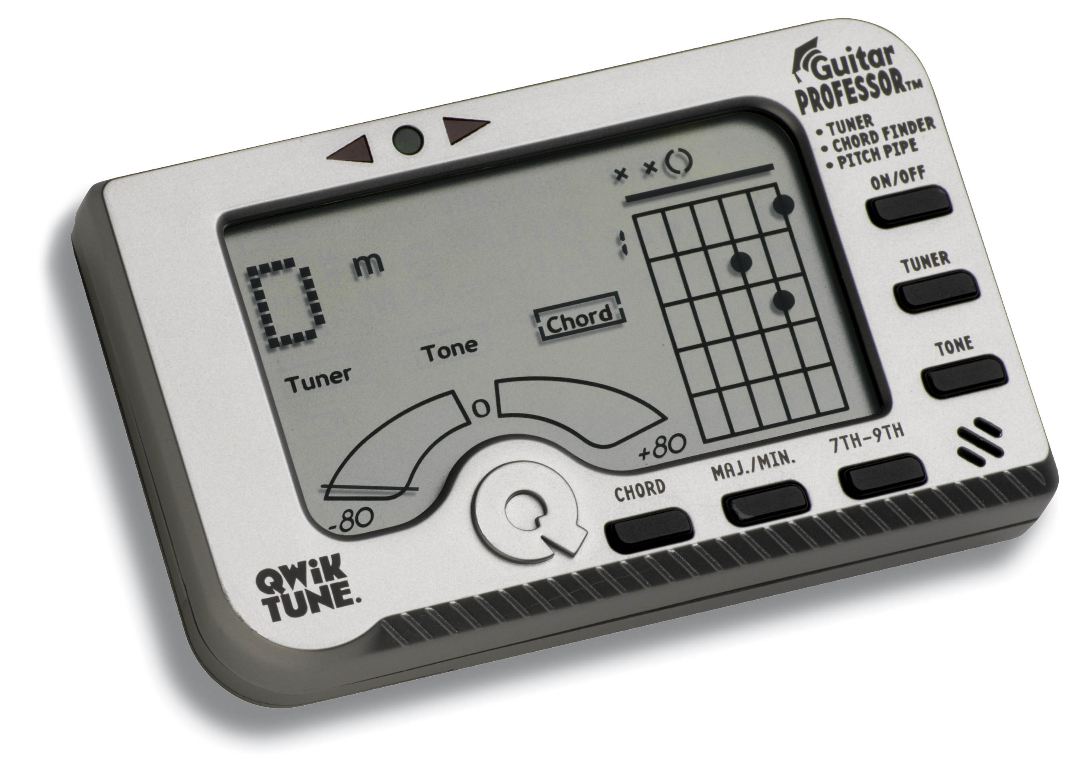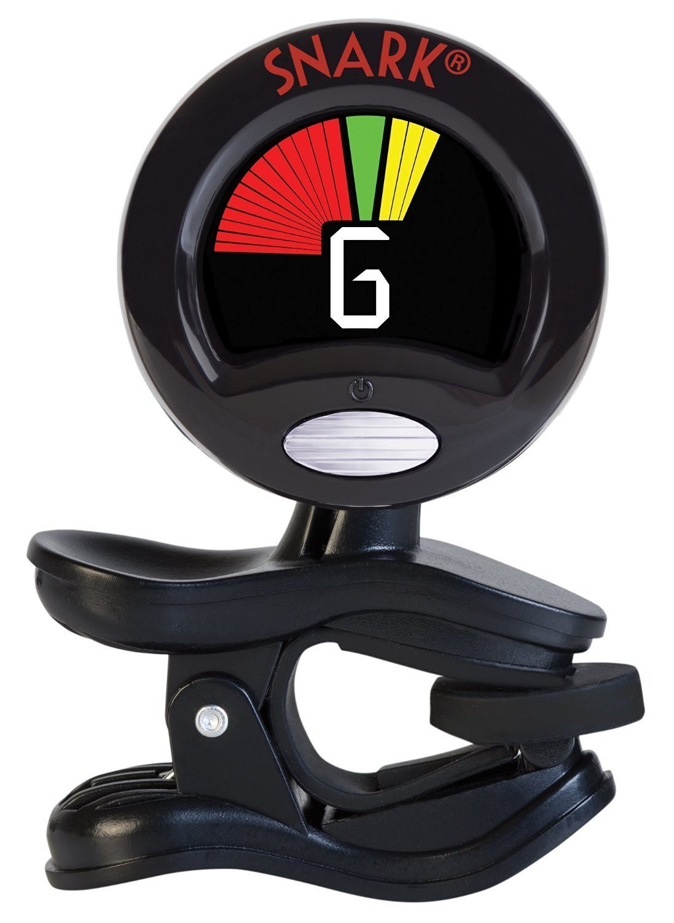

Chromatic tuner- another style of tuner that clips on to surfaces and displays simply the note and the range of the note it is hearing, yelling indicating sharp and red indicating flat.

*Source: https://www.amazon.com/Snark-SN5X-Guitar-Violin-Current/dp/B01H74YV56*

Qwik tune- Displays a chord and the chord chart for that chord. This is used for guitarists and shows the fingering on the 6 strings of a guitar.

*Source: https://www.amazon.com/Qwik-GP1-Guitar-Professor-Tuner/dp/B000M23OQ8*